**Additional Task – (LO1) – Assignment (Task 6)**

**As you have done this in a previous unit all you need to do is validate the index.html page, stylesheet.css page using the web services below. Update any critical errors found.**

All the **HTML**, **CSS & JavaScript** should be **standards compliant** and **validate** against current **W3C standards**.

**Save** to docs sub-folder & **submit to Canvas** on completion

Visit -[The W3C Markup Validation Service](https://validator.w3.org/) - Screenshot **showing HTML Validation** of **index.html page.**

Visit - [The W3C CSS Validation Service](https://jigsaw.w3.org/css-validator/) - Screenshot **showing CSS Validation** of **styles.css page.**

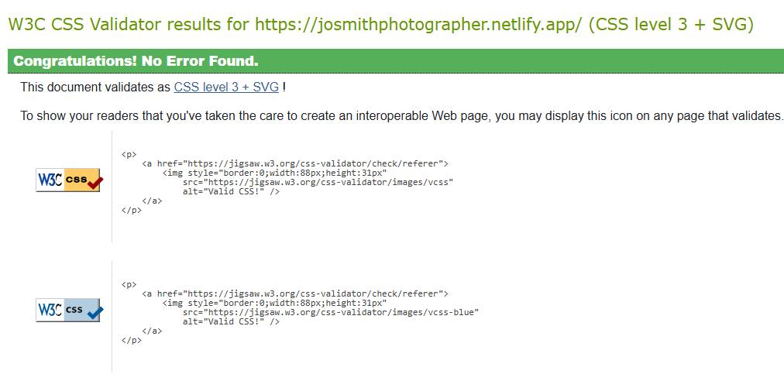

Visit - [Best JavaScript Validator Online](https://codebeautify.org/jsvalidate) - Screenshot **showing JavaScript Code Validation** of **any JavaScript Coding that you have used.**

